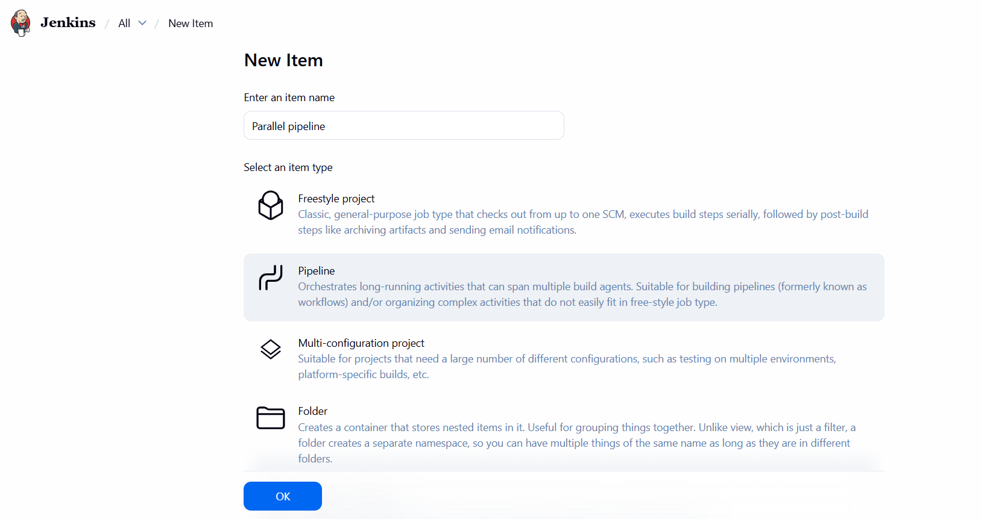
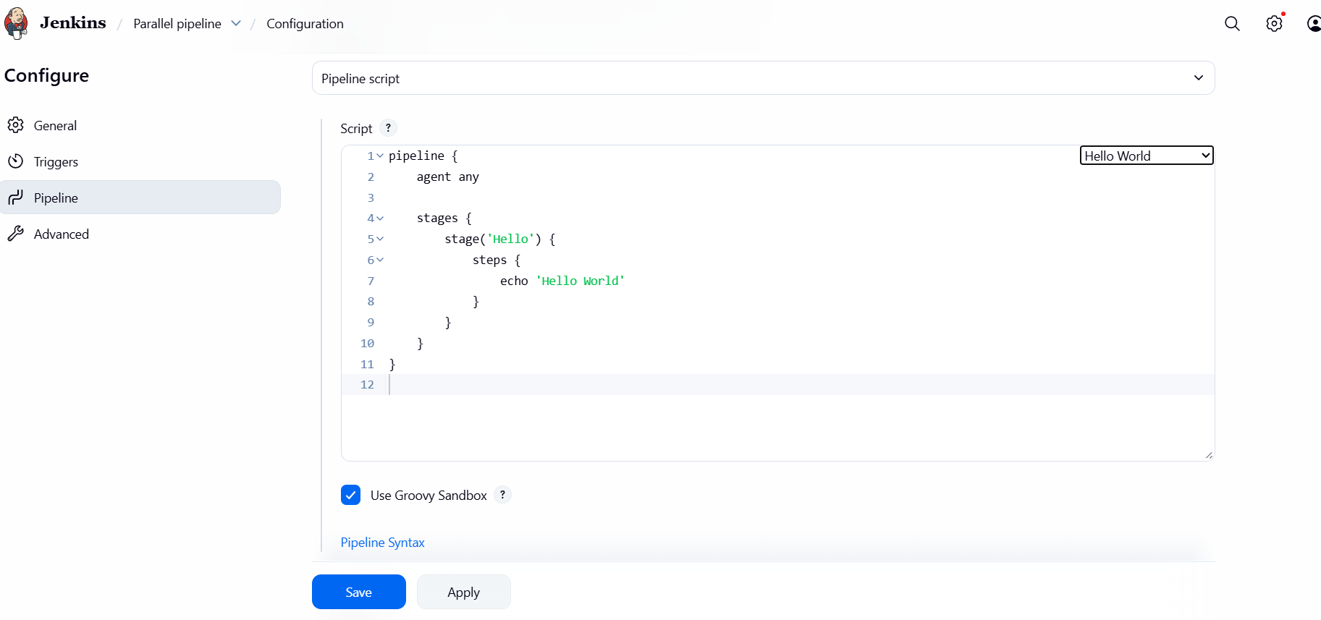
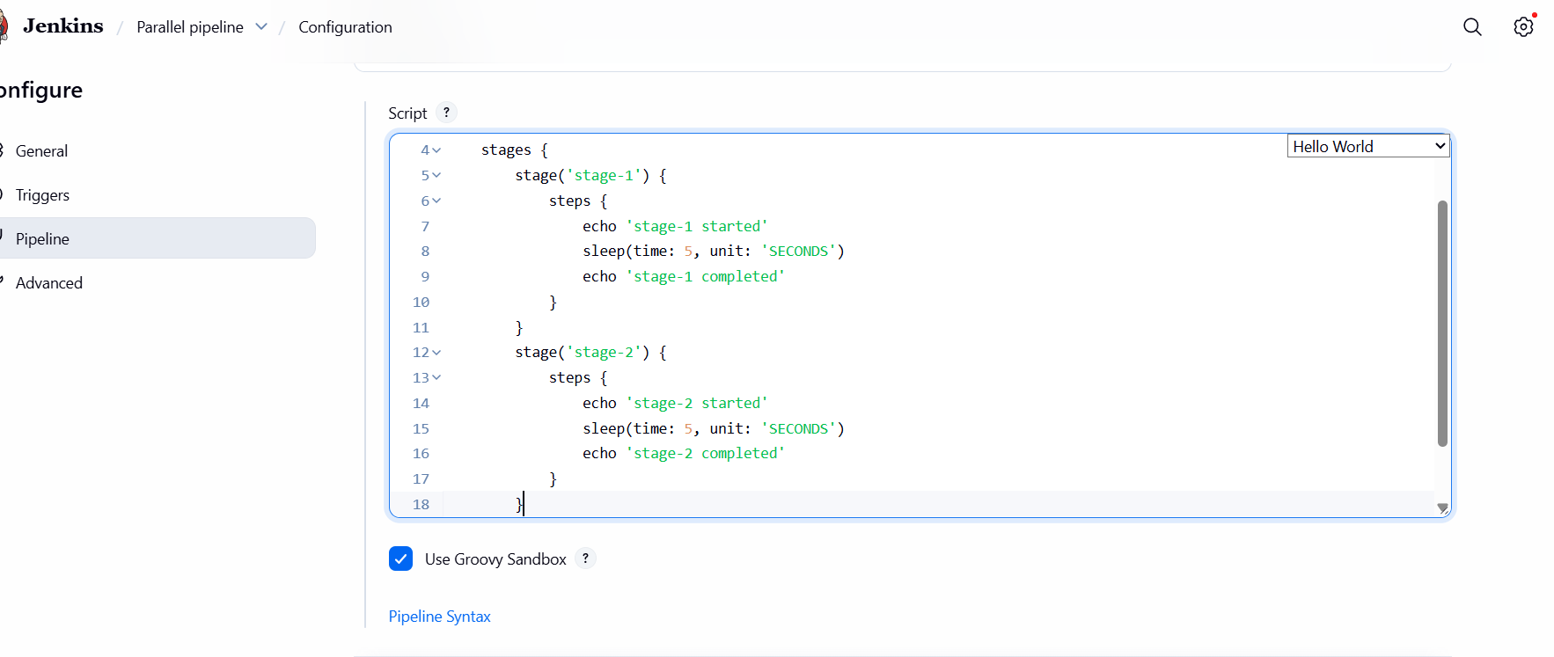
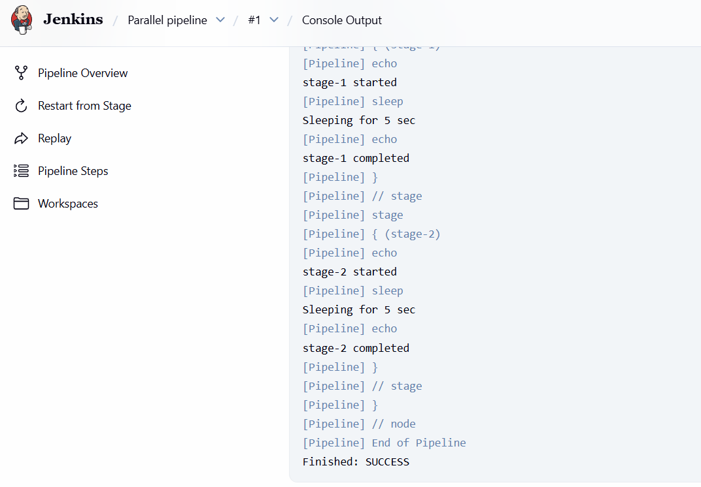
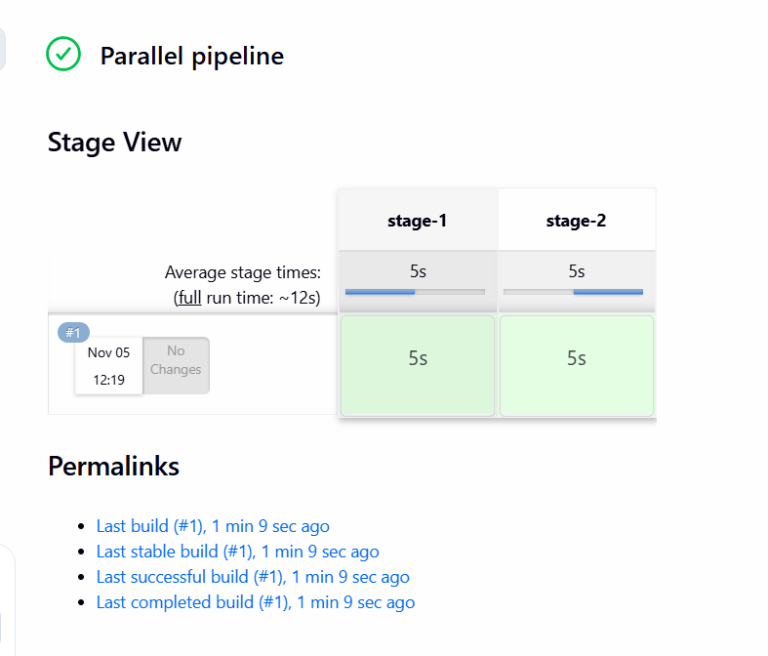
- As we can see in the output that stage 1 is started and went to sleep for 5 seconds as we mentioned in script and later 5 seconds stage-1 is completed. Same for stage -2.
- But the average time is taken is 12 seconds overall to execute this 2 stages.
- So, this are executing in sequential order.

Now, we execute the same script by creating parallel parent stage and inside it we create a parallel block and will see the changes in average time of execution of the stages.

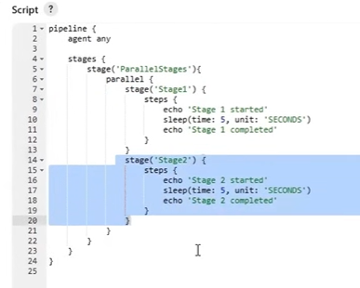

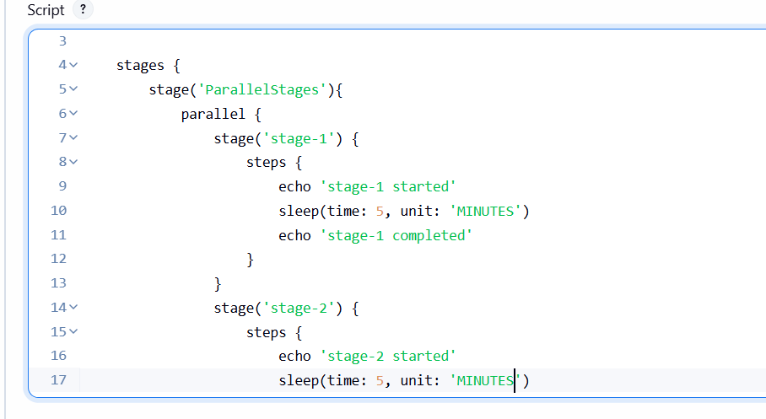

- Change time into minutes in place of seconds to see improvement.

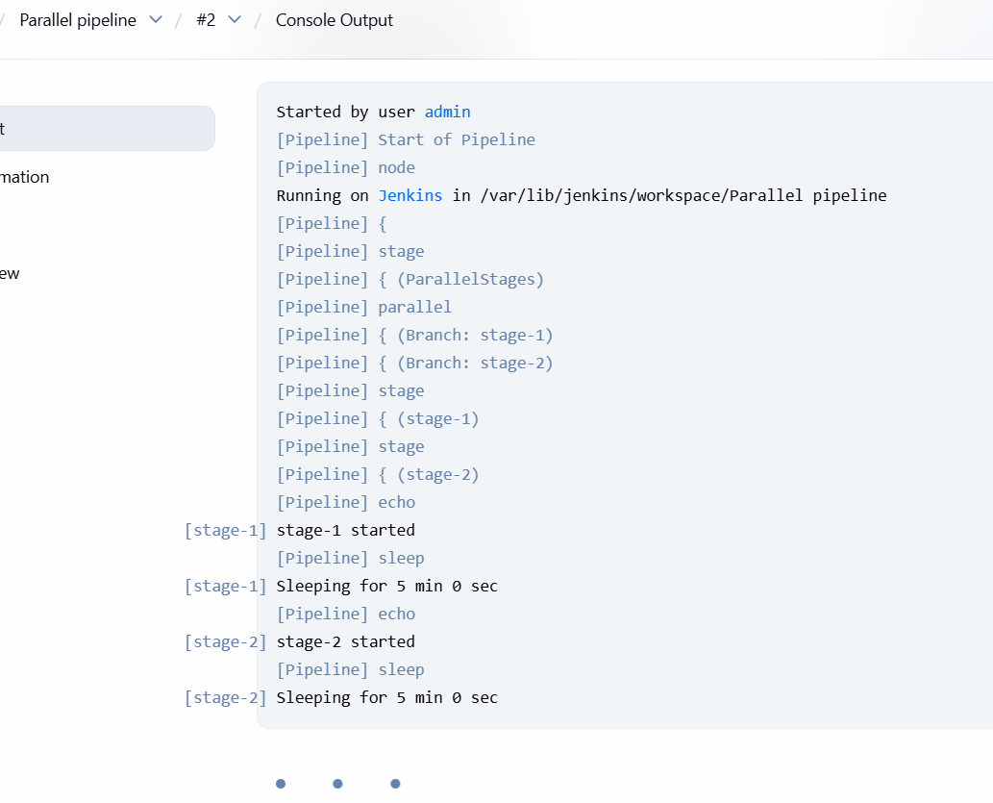

- We can see stage-1 and stage-2 started in parallel time and waiting for 5 minutes as per our script.
- Here stage 2 doesn’t wait until the stage 1 completion. Both started in parallel time.

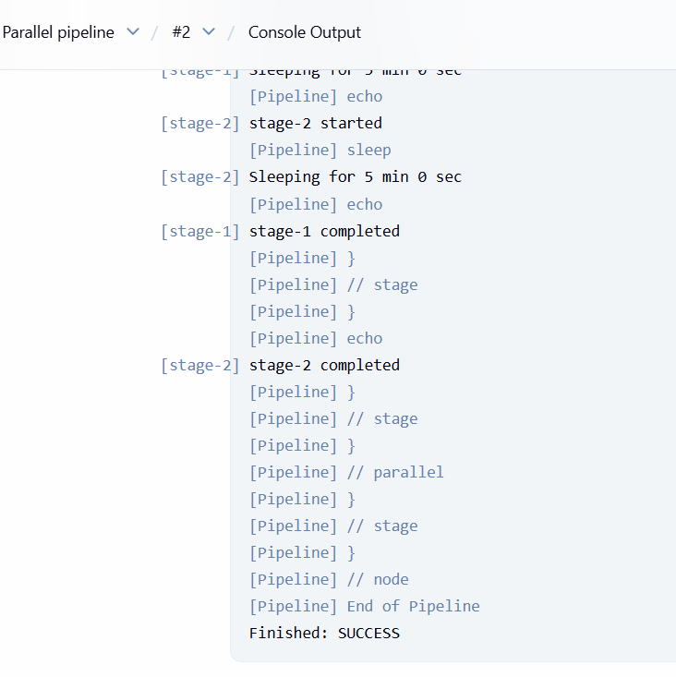

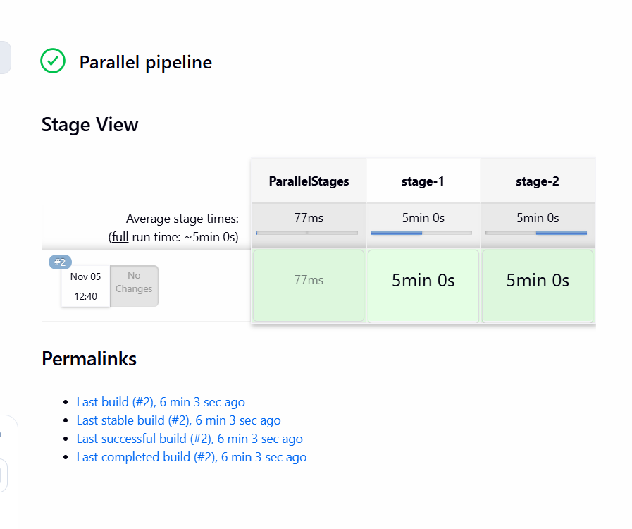

- As we can see in final output the average time took is 5 minutes 0 seconds for executing both stages in parallel way.
- By this parallel pipelines, we can reduce our build time by 50% which are independent to each other to improve efficiency.

